MASTER OF TECHNOLOGY

PROJECT REPORT

HDB RESALE RECOMMENDER SYSTEM

TEAM MEMBERS

YEE WEI LIANG - 1

JOVIN TOH - 2

JEON SUNG MIN - 3

AHMED SYALABI SEET – 4

**1. EXECUTIVE SUMMARY**

**2. BUSINESS PROBLEM DESCRIPTION**

* 1. **PROJECT OBJECTIVE**

According to Straits Times article published on 8 Apr 2021, delays in Build-to-Order (BTO) flats, rising private property prices and improving market sentiment drove demand in the Housing Board resale market, sending prices climbing for the ninth straight month. [[Link](https://www.straitstimes.com/business/property/hdb-resale-prices-rise-for-9th-straight-month-in-march-with-cash-over-valuation)]

Armed with limited knowledge, aspiring homeowners often must second guess the suitable price to pay for a resale flat. For example, when a listing is listed at a lower price than what the past transactions or neighbouring listings are showing, it could be due to undesirable conditions. On the other hand, if the pricing is higher than valuation, prospective buyer ends up paying more.

Hence, our project would like to provide prospective resale flat buyers with a tool to predict the pricing to negotiate with resale flat sellers, with existing domain knowledge obtained through Data.gov

**2.2 MARKET RESEARCH**

Compare PG, 99.co, etc and comment what they do not have.

Compare with existing recommender systems made by other people.

Only past 5 transactions, missing predictive capability

Important features that are affecting price

**2.3 SUCCESS MEASUREMENTS**

Think of ways to measure system’s success.

Example like incorporate forecasted price and compare with actual price on various websites.

**3. KNOWLEDGE MODELING**

Knowledge modelling can be decomposed into three main stages, namely;

1. Knowledge identification
2. Knowledge specification
3. Knowledge refinement

Various activities are carried out during each of these stages and the crux of the model construction lies in stage (ii), Knowledge specification.

<http://ksi.cpsc.ucalgary.ca/KAW/KAW98/schreiber/>

**3.1 KNOWLEDGE IDENTIFICATION**

*Table 1: Knowledge source and acquisition technique*

|  |  |  |  |
| --- | --- | --- | --- |
| **S/N** | **Source of information** | **Insights from information source** | **Knowledge acquisition technique** |
| 1 | Data.gov.sg | Historical resale flat prices from 1990 to current.  Provides data for the prediction model training. | Extracted using Data.gov.sg API |
| 2 | PropertyGuru.com.sg | Individual property listings posted by property agents, inclusive of features such as listing price, type of flat model, location, etc  Provides listing prices available for comparison with prediction values | Web scrapping to obtain actual listings of HDB resale units available to the public |
| 3 | Generic population | Obtain a ranking of the features that are most important to users for the recommender system. | Anonymous online survey |

**3.2 KNOWLEDGE SPECIFICATION**

*Table 2: Survey responses on feature importance when scouting for a resale flat*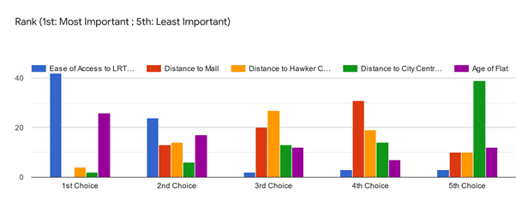

Based on the survey results of 74 respondents on key factors affecting the price of an HDB resale flat, we have derived the following equation for the scoring of a resale HDB flat listing:

**3.3 KNOWLEDGE REFINEMENT**

**4. SOLUTION**

**4.1. PROJECT IMPLEMENTATION**

To detail system development and testing approach.

Explain in detail, the whole data flow and process flow. From data.gov to database to output website.

**4.2 PROJECT PERFORMANCE & VALIDATION**

To prove project objectives are met.

Make a statistical comparison between prediction and actual listing prices.

Possibly map out the recommended listings on a geographical map and show the distances for all the amenities nearby.

**5. CONCLUSION**

* 1. **PROJECT CONCLUSION**

Findings and recommendations.

What to improve on.

**6. APPENDIX**

**6.1 PROJECT PROPOSAL**

**6.2 SKILLS OF MODULAR COURSES: MR, RS, CGS**

|  |  |  |
| --- | --- | --- |
|  |  |  |
| **1** |  |  |
| **2** |  |  |
| **3** |  |  |

* **Web scrapping - CGS**
* **Prediction Tree Modelling - MR**
* **User-based Recommender system – RS**

**6.3 Installation and User Guide**

**6.4 Individual Project Reports**

**6.5 List of Abbreviations**

**6.6 References**